
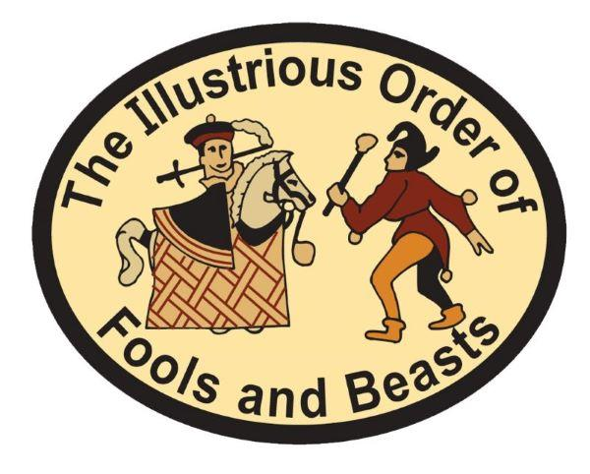
Unconvention 23-25 October 2026
Kent

Open to all budding or experienced Fools, Beasts and Morris Characters from any team from the Ring, Open or Federation, or independent. A truly JMO event!
This year, I am pleased to announce that East Kent Morris are hosting the 2026 event! Our base will be the Faversham Cricket Club, Selling Road, Faversham, Kent, ME13 8XF. We’re back to indoor camping this year. There are showers available. There is plenty of room for Motor Homes and Caravans, and camping for the hardy Fools! The Saturday tour will be in Canterbury City Centre, as part of the Canterbury Arts Festival. There will be the usual mix of workshops, including a talk on Kent Hooden Horses, plus the AGM on Sunday. The fee has been capped to £90; this includes Friday supper, two breakfasts, Saturday lunch, and Feast. Where else could you go for full board for a weekend at this price? Please contact Robert for pro rata prices for part of the weekend. Children under 16 half price! (Trigger says he will eat them, I think he misses the point!)
NameDelegate #1 | email | Tel | Accommodation (pls tick)
 |  |  | Bed
Side | Character & Name (Fool/Beast/Other) | Dietary Requirements | Motor home Caravan/tent
 |  |  | Local B&B
Name Delegate #2 | email | Tel | Accommodation (pls tick)
 |  |  | Bed YES
Side | Character & Name (Fool/Beast/Other) | Dietary Requirements | Motor home Caravan/tent
 |  |  | Local B&B

Closing date for Applications: 3rd October 2026.

Yours, Robert Chisman, Scrivener and Convenor
Return this form via post with an old-fashioned type cheque for the full amount (£90 pp) payable to "The Illustrious Order of Fools and Beasts" to Robert Chisman, Fools and Beasts Convener, 1, Treverbyn Road, St. Austell, Cornwall, PL25 4EU Tel:01726 68178 mobile 07970063922.OR submit form via t’internet and pay by BACS –09 01 55 74995188 use name or side as reference, please. Or pay cash or card at the event – but Trigger says can he have the money earlier than that if possible.
E-mail: triggertrotter1@aol.com
Follow Trigger on Facebook and well dunno about X anymore.

Trigger Morris-Horse, or The Illustrious Order of Fools and Beasts.
Provision of email address indicates willingness to be included on IOFB e-mail list. If you DO NOT wish your email address to be included, please tick HERE ......

